Grep Command in Linux and Unix

# The grep command can **search for a string in groups of files**. When it finds a pattern that matches in more than one file, it prints the name of the file, followed by a colon, then the line matching the pattern.

## **Syntax:**

## **grep [options] pattern [files]**

**Options Description**

**1. -c** : This prints only a count of the lines that match a pattern

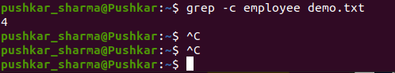

**2.fgrep -h :** Display the matched lines, but do not display the filenames.

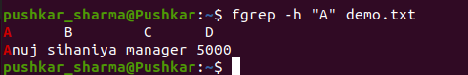

**3.-i :** Ignores, case for matching

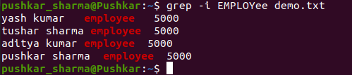

**4.-l :** Displays list of filenames only.

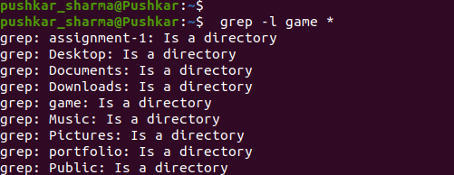

**5.-n :** Display the matched lines and their line numbers.

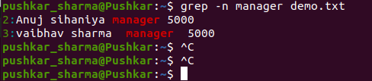

**6.-v :** This prints out all the lines that do not matches the pattern

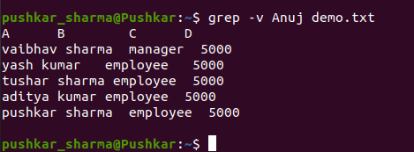

**7.egrep :** Displays list of directory and filenames .

 